Own Your Health
“MORE ISN’T ALWAYS BETTER” CAMPAIGN

The purpose of this campaign is to reduce the overuse of commonly overprescribed tests and procedures – and their associated costs and risks – by encouraging health care consumers to be active participants in their health. To promote this message, we’ve created marketing materials that you can post in your offices and facilities, on your website, and through social media.
ABOUT OWN YOUR HEALTH

Own Your Health is presented by the Washington Health Alliance. The Washington Health Alliance is a nonprofit organization where the people who give, get and pay for health care work together to improve health care quality and value in Washington state.

HOW TO USE THESE MATERIALS
In addition to the social media posts on the following pages, we’ve created a poster series available for download, and graphics you can post on your website blogs & news sections.

Posters & Flyers
We’ve created two different posters and flyers you can download and print. Suggestion: post flyers and posters in your office, community center, lobby, breakroom, or anywhere visible to health care consumers.

Contact Leslie Bennet at lbennett@wahealthalliance.org if you’d like to co-brand your posters with your organization logo.

Posters to choose from:

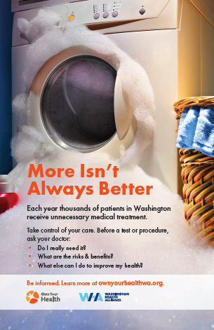 | 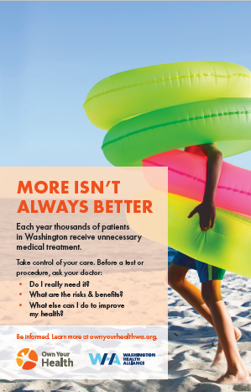

Click here to download campaign posters.

Messages & Images for Social Media Posts
On the following pages, you will find a series of messages and digital graphics for you to use on social media, including Facebook, LinkedIn and Twitter.

Click to download social media graphics

Images to choose from in our More Isn’t Always Better campaign folder:

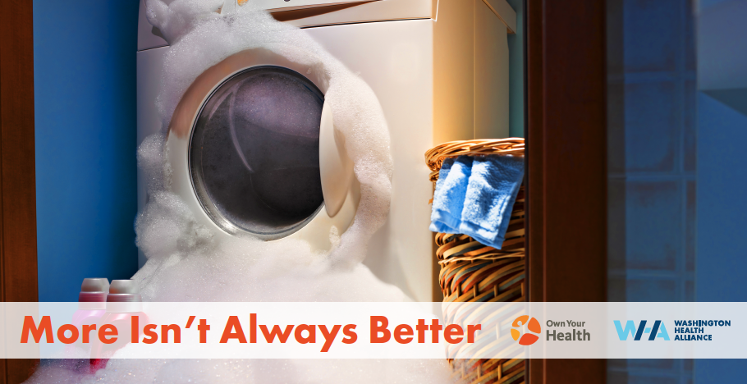
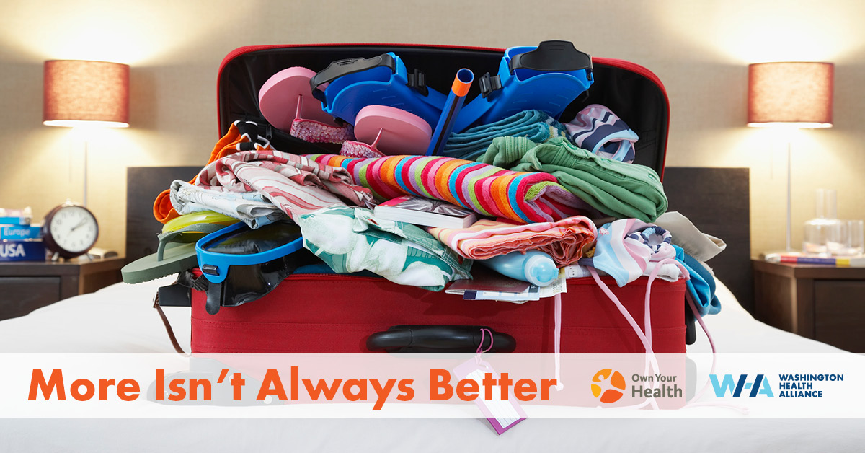
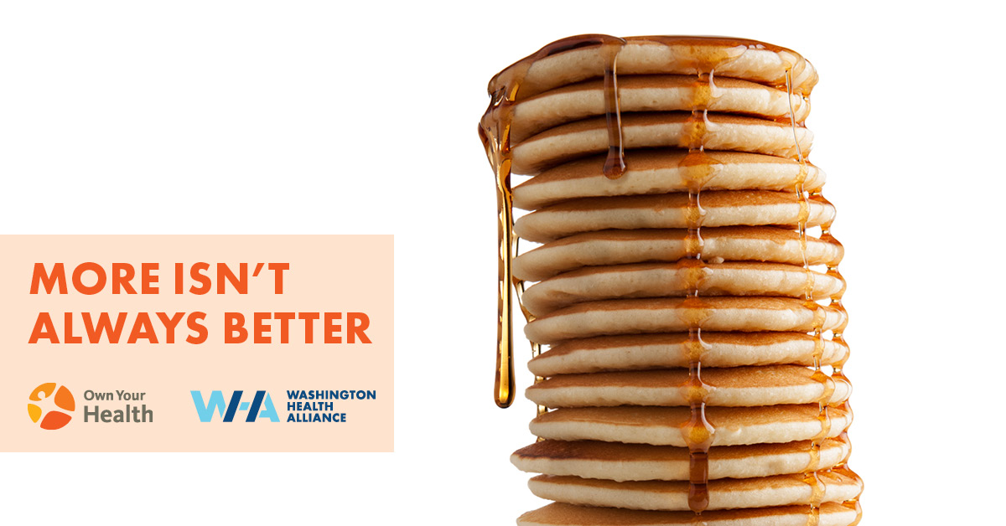

We recommend posting at least twice a week (in this case, MORE is better), at different times of the day to get visibility with a wider audience. Experiment with combining different messages and images. Don’t be afraid to schedule the same ad at different times of the day over the course of the week – not everyone who follows you will see your ads each time you post.

Best Times to Post
- Best posting times for LinkedIn: between 10am – 11am on Tuesday, Wednesday and Thursday.

- Best posting times for Facebook: between 1pm – 4pm, Thursday – Sunday.

- Best times to post on Twitter: between 9am-10am, Wednesday and Friday.

To post to your social account, just follow these steps:

Step 1: Choose an image from our campaign resources page.

Step 2: Find the content below that you want to use and cut and paste the content into the post. Remember to include the hashtags.

Step 3: Hit post!

MESSAGES FOR FACEBOOK AND LINKEDIN

Message 1: The right amount of care

Content to cut and paste (from headline through hashtags):

MORE ISN’T ALWAYS BETTER
When it comes to your health, more can be better. More exercise. More fruits and vegetables. More sleep. But not always more tests and procedures. A talk with your doctor is the smart way to make sure you end up with the right amount of care: not too much, not too little.

Before a test or procedure, ask your doctor:

- Do I really need it?
- What are the risks & benefits?
- What else can I do to improve my health?

Be informed.

Visit Own Your Health to learn how you can take control of your care.
#MoreIsntAlwaysBetter #OwnYourHealth #GoodHealth #SharedDecisionMaking #HealthyWA #ReduceOveruse

Message 2: TOO MUCH of a good thing

Content to cut and paste (from headline through hashtags):

MORE ISN’T ALWAYS BETTER
When it comes to medical tests, procedures and medications, it’s possible to have TOO MUCH of a good thing. The best care is the right care. When you weigh the benefits, risks and costs – physical, emotional and financial, you can then make a choice that’s right for you.

Before a test or procedure, ask your doctor:

- Do I really need it?
- What are the risks & benefits?
- What else can I do to improve my health?

Be informed.

Visit Own Your Health to learn how you can take control of your care.
#MoreIsntAlwaysBetter #OwnYourHealth #GoodHealth #SharedDecisionMaking #HealthyWA #ReduceOveruse

Message 3: Unnecessary medical treatment

Content to cut and paste (from headline through hashtags):

MORE ISN’T ALWAYS BETTER

Each year thousands of patients in Washington receive unnecessary medical treatment.

Take control of your care. Before a test or procedure, ask your doctor:

- Do I really need it?
- What are the risks & benefits?
- What else can I do to improve my health?
Be informed.

Visit Own Your Health to learn more.
#MoreIsntAlwaysBetter #OwnYourHealth #GoodHealth #SharedDecisionMaking #HealthyWA #ReduceOveruse

Message 4: It’s your health

Content to cut and paste (from headline through hashtags):

MORE ISN’T ALWAYS BETTER

Each year thousands of patients in Washington receive unnecessary medical treatment. When your doctor suggests a treatment, it’s important for you to be an active participant in the final decision. After all, it’s your health.

Here are some questions to ask to help you make the decision that is best for you:

- Do I really need it?
- What are the risks & benefits?
- What else can I do to improve my health?
Take control of your care.

Visit Own Your Health to learn more.
#MoreIsntAlwaysBetter #OwnYourHealth #GoodHealth #SharedDecisionMaking #HealthyWA #ReduceOveruse

Message 5: Take an active role

Content to cut and paste (from headline through hashtags):

MORE ISN’T ALWAYS BETTER

By talking with your doctor, you can weigh the benefits, risks and costs – physical, emotional and financial, of a test or procedure, and then make a choice that’s right for you. If your doctor understands what matters to you, they will be better able to help you with important decisions down the road.

Take control of your care. Before a test or procedure, ask your doctor:

- Do I really need it?
- What are the risks & benefits?
- What else can I do to improve my health?
Be informed.

Visit Own Your Health to learn more.
#MoreIsntAlwaysBetter #OwnYourHealth #GoodHealth #SharedDecisionMaking #HealthyWA #ReduceOveruse

MESSAGES FOR TWITTER
(280 Character Limit)

Message 1: Ask your doctor

Content to cut and paste (from hashtag through period):

#MoreIsntAlwaysBetter – Before a test or procedure, ask your doctor 1) Do I really need it, 2) what are
the risks & benefits, 3) what else can I do to improve my health? Visit Own Your Health https://bit.ly/OYHMIAB to learn how you can take control of your care.

Message 2: The right amount of care

Content to cut and paste (from hashtag through period):

#MoreIsntAlwaysBetter – When it comes to your health, more can be better. More exercise. More vegetables. More sleep. But not always more tests and procedures. A talk with your doctor is the smart way to make sure you end up with the right amount of care. Visit https://bit.ly/OYHMIAB to learn more.

Message 3: Do I really need it?

Content to cut and paste (from hashtag through period):
#MoreIsntAlwaysBetter – Before a test or procedure, ask your doctor “Do I really need it?” Each year, WA patients receive thousands of test & procedures that may not be necessary – or even cause harm. Visit https://bit.ly/OYHMIAB to learn how you can take control of your care.
Message 4: What are the risks & benefits?

Content to cut and paste (from hashtag through period):

#MoreIsntAlwaysBetter Before a test or procedure, ask your doctor “What are the risks & benefits?”
For some, the potential physical, emotional, and financial harm resulting from some screenings,
diagnostic and pre-operative tests can outweigh the benefits. Visit https://bit.ly/OYHMIAB to learn
more.

Message 5: What else can I do to improve my health?

Content to cut and paste (from hashtag through period):

#MoreIsntAlwaysBetter – Before a test or procedure, ask your doctor “What else can I do to improve
my health?” Some tests & procedures may be unnecessary or inappropriate given your particular
circumstances. Visit Own Your Health https://bit.ly/OYHMIAB to learn how you can take control of
your care.

